Mini Project Report: Heart Disease Prediction using Machine Learning

1. Basic Details
Name: Piyush Khandelwal
Enrollment No: 2302320167
Course & Semester: B.Tech CSE – 6th Semester
Project Title: Heart Disease Prediction using Machine Learning

2. Problem Statement
Heart disease is one of the leading causes of death worldwide. Early prediction can help in timely treatment and prevention. This project aims to predict the presence of heart disease using machine learning algorithms like Logistic Regression, Random Forest, and AdaBoost.

3. Dataset Description
Dataset Source: Kaggle
Dataset link: https://www.kaggle.com/datasets/johnsmith88/heart-disease-dataset
Records: 1025
Features: 14
Target Variable: target (0 = no disease, 1 = disease).
Important Features: age, sex, chest pain type (cp), resting blood pressure (trestbps), cholesterol (chol), fasting blood sugar (fbs), maximum heart rate achieved (thalach), and the target variable (0 = no disease, 1 = disease).

4. Exploratory Data Analysis (EDA)
Dataset preview and structure were analyzed. Histograms, correlation heatmaps, and count plots were used.
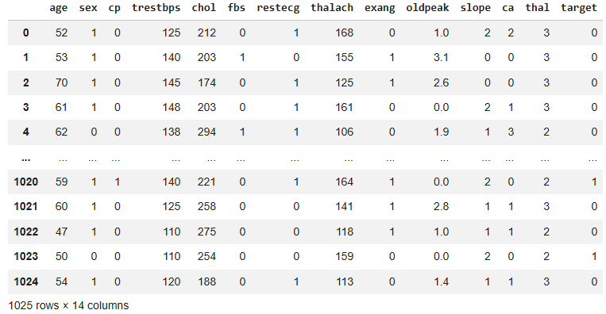
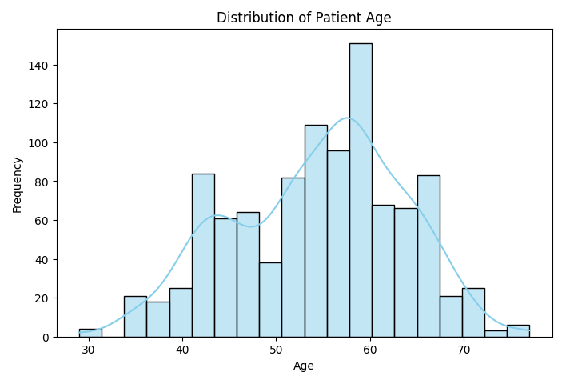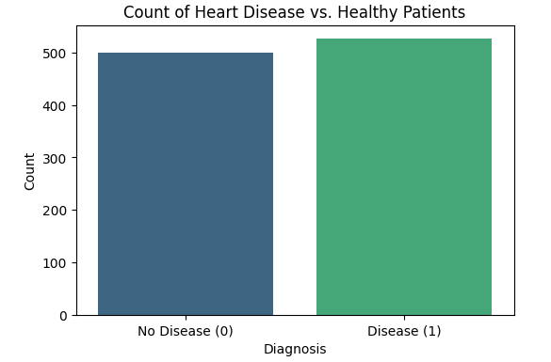

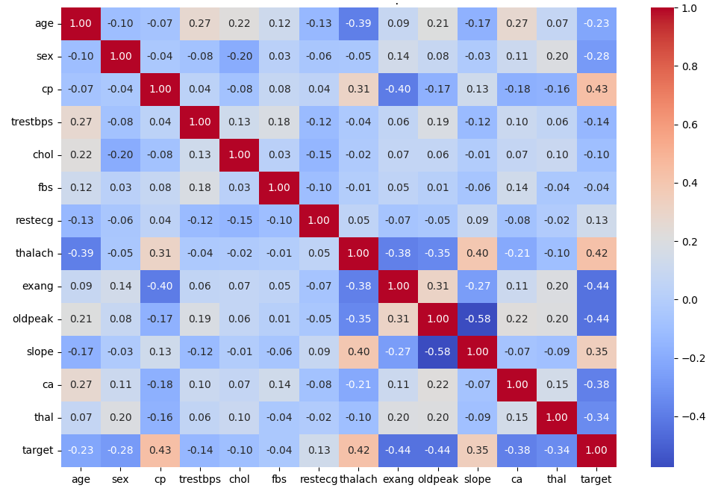
Observation: Features like chest pain type (cp) and maximum heart rate (thalach) show a positive correlation with the target variable, indicating they are strong predictors of heart disease.

5. Data Preprocessing
- Missing Values: The dataset was checked using df.info() and found to have 0 null values across all 1,025 rows.
- Feature Scaling: Standard scaling was applied to normalize numerical features.
- Data Splitting: The data was divided into training and testing sets to evaluate model performance on unseen data.
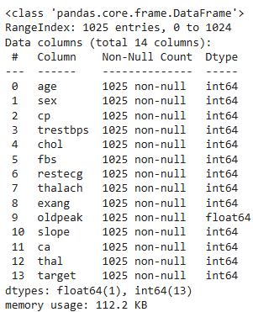

6. Methodology
- Algorithms used: Logistic Regression, Random Forest, AdaBoost
- Data preprocessing
- Data cleaning and feature scaling.
- Splitting data into training (80%) and testing (20%) sets.
- Model training
- Evaluation using metrics
- Comparison of models

7. Implementation
Platform: Google Colab
Libraries: pandas, numpy, matplotlib, seaborn, sklearn

8. Results and Analysis

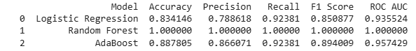

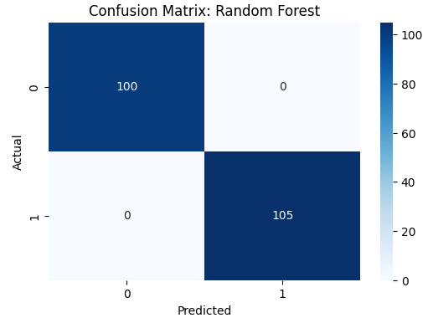

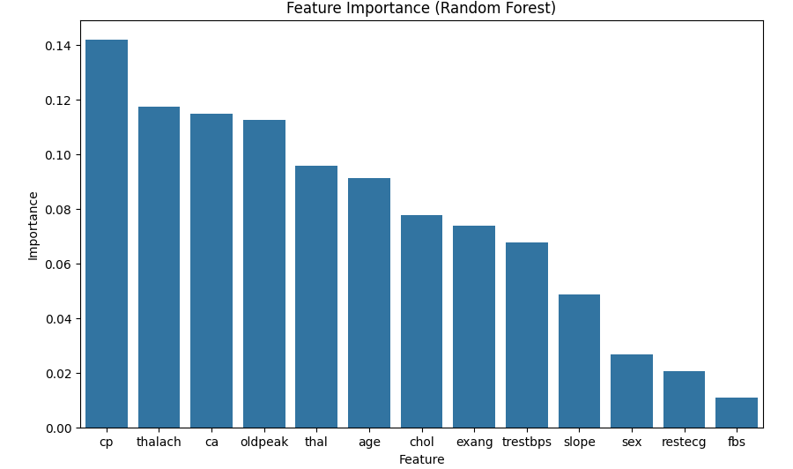

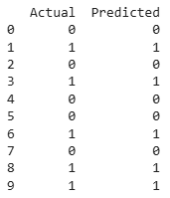

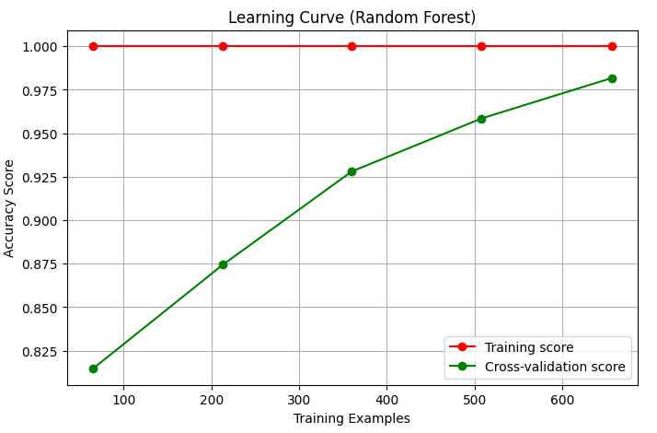
My observation: By observing numerical values we can say that random forest performed best but it is overfitting the model completely which is not a good thing.

9. Model Comparison
Random Forest performed best due to handling complex patterns effectively.

10. Conclusion
The project successfully predicted heart disease using ML models. Random Forest was the most accurate.

11. Future Scope
Future improvements could include hyperparameter tuning to prevent potential overfitting in the Random Forest model and testing the system with more diverse real-world datasets.

12. Real-world Application
Healthcare systems, hospitals, early diagnosis tools

13. Attachments
Link: https://colab.research.google.com/drive/1PYArTfVw0_sJlNWhkNKz82MdxwzRrk1F?usp=sharing

